# Cupar and District

# Floral and Horticultural Society

# Annual Flower & Craft Show

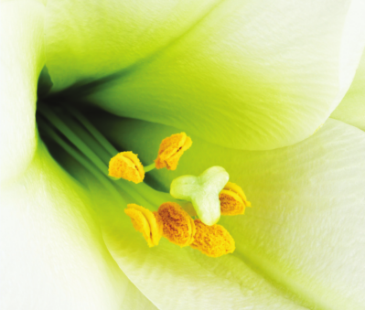

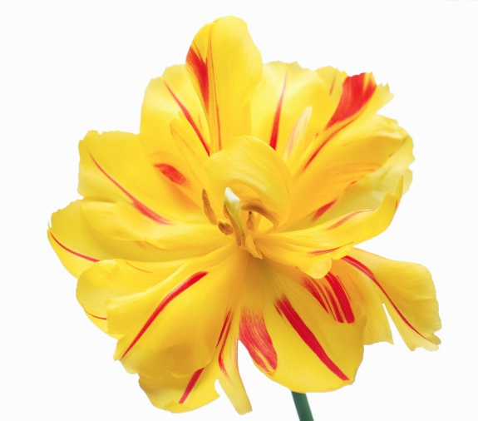

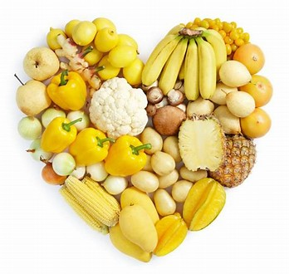

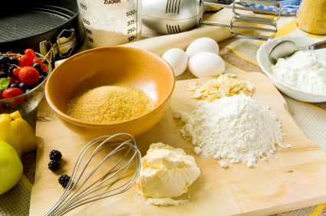

Saturday 11th August 2018

Corn Exchange, Cupar, Fife

Open from 10am – 4.30pm

Classes available for all levels and ages of competitors

**Schedules available now**

|  |  |
| --- | --- |
| * **Cut Flowers including East of Scotland Sweet Pea Championship, Dahlia, Begonias** * **Pot Plants** * **Wine** * **Floral Art** * **Children’s Classes** * **School’s & Nurseries Competitions** * **Novice Section** | * **Vegetables** * **Garden Competitions** * **Photography** * **Women’s Institute Class** * **Industrial including baking, handicrafts & needlework** * **Fruit and Herbs** * **Bonsai Classes alongside display** |

Refreshments Served All Day

Fi Admission: £2.00 / Concessions £1.50 / Children under 12 Free (Accompanied by an adult)

[WWW.CUPARFLOWERSHOW.CO.UK](http://WWW.CUPARFLOWERSHOW.CO.UK)

Facebook.com/cuparflowershow





**Also, there is a special GOLD theme running through this year’s show as the Cupar Flower Show supports Childhood Cancer Awareness Month through Toby’s Magical Journey and the Glow Gold Campaign**